

**Artificial Intelligence(AI-2002)**

**Project Report**

**Team Members:**

Moiz Ahmed Khan 22k-4795

Izaan Asad 22k-4704

Jahanzaib Sheikh 22k-4789

Game Rule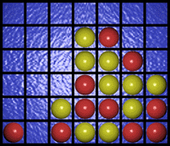s

Connect Four is a two players game that takes place on a 7x6 rectangular board placed vertically between them. One player has 21 yellow coins and the other 21 red coins. Each player can drop a coin at the top of the board in one of the seven columns; the coin falls down and fills the lower unoccupied square. Of course, a player cannot drop a coin in a certain column if it's already full (i.e. it already contains six coins).

Even if there's no rule about who begins first, we assume, as in chess, that the lighter side makes the first move. We also use chess notation to represent a square on the board. That is, we number rows from 1 to 7 starting from the bottom and the columns from A to G starting from the leftmost.

The object of the game is to connect four coins vertically, horizontally, or diagonally. If the board is filled and no one has aligned four discs then the game is drawn (i.e. after 42 moves if no one wins).

Look at the following examples...

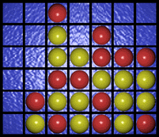  
  
  
This picture represents a win by yellow  
  
  
  
  
  
  
  
  
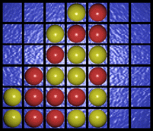  
  
  
This picture represents a win by red  
  
  
  
  
  
  
  
  
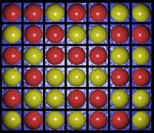  
  
  
This picture represents a draw

**Project Objectives**

We intend to make a game in which the computer is able to play intelligently the game of connect four. The game involves deep enough strategies that make the game interesting from the point of view of invoking artificial intelligence. We intend to analyze the board to about 4 depths before making the move. This would involve the successive analysis of the strength of the computer as a consequence of effective moves. The usage of the mouse makes the interface very user-friendly enabling us to be able to make his move at a click. The challenge also lies in playing the game at one level and invoking the algorithm accordingly. If possible, we would like to make the game playable through networking as well.

**Program Design**

The program deals with artificial intelligence. The algorithm used in this program is Alpha-Beta pruning which makes the computer very intelligent. The computer is required to use its intelligence against each move by the user which will be dependent on the developed algorithm. The more complexity and efficiency of the algorithm the better will be the moves made by the computer and will be tougher for the user to prove him/herself smarter than the machine.  
  
The platform that is used for developing the project in Visual Studio Code. We prefer Visual Studio Code as the operating platform because of its ease of use and easy debugging abilities. We will be implementing functions (the number will depend on the algorithm developed) as Python is mainly an AI (Artificial Intelligence) language. We plan to use the Input Output functions and also the **pyGame** library for the graphical part of the program for **GUI** (Graphical User Interface).

**Sample Input & Output**

**Input:**

As soon as the user runs the program the game will start and there will be an option window asking the user color choice of ball. After the initial settings have been set by the user the game begins. The user would be allowed to click on the pointers positioned above each column.

**Output:**

With the click of the mouse in the specified column, the coin would be inserted in the appropriate location which is the lowest unoccupied slot. The computer would then analyze the game field and would then go to subsequent depths in order to be able to make the smartest move.  After having decided on the move the computer would then insert the coin in the decided slot. At any stage, the user will be allowed to pause or resume the game.

**This is a journey in time...**